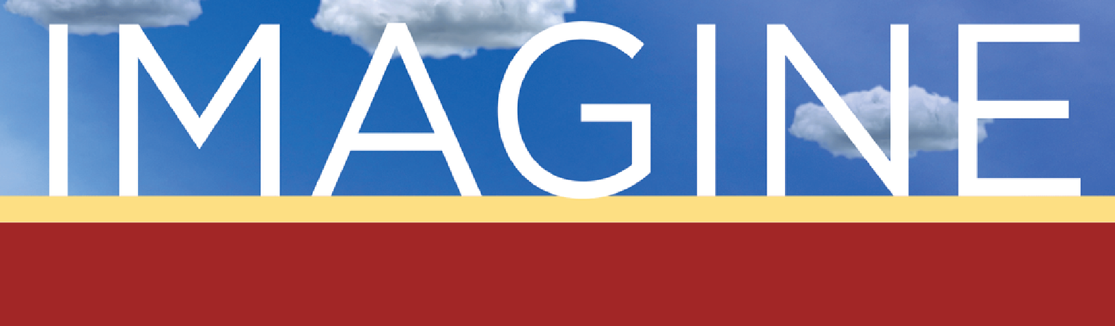
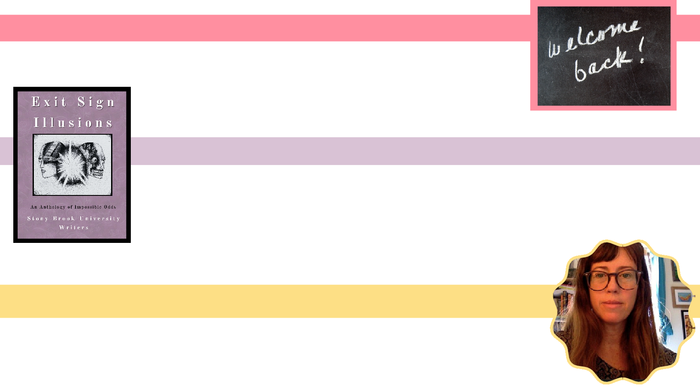
Feb 4 – Welcome Back Mixer
_{SPRING} W E D N E S D A Y S
Melville N3045 “Fishbowl” 12:30-1:30 PM
2026
Kick off the semester with fellow writers and readers. Join us for
games, conversations, and, of course, pizza!

March 11 – Exit Sign Illusions Reading
Come support the publication of Exit Sign Illusions, an anthology of writing created by the students from this fall’s CWL 320 course, with readings from the anthology and a discussion about how the book was made.

April 8 – Starting a Small Press with Lauren Belski
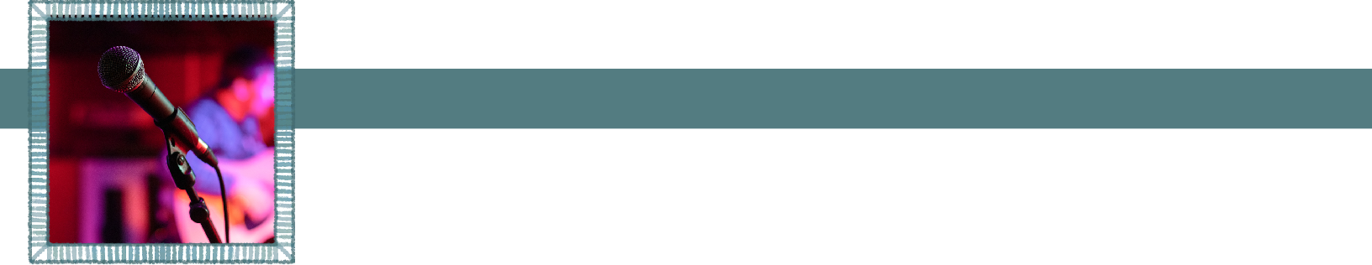
Interested in the world of independent publishing? Join Lauren Belski, founder of Under the BQE Press, for a reading and conversation on how to start and sustain a small press.

May 6 – Student Showcase
A semester’s worth of work, shared out loud. Wrap up the year with a reading featuring nominated undergraduate writers sharing pieces across genres.


@wolfiewriters
To request accommodations or more information, please email cwlundergrad@stonybrook.edu

